# Artificial Intelligence: Machines Solving Humanly Issues

İdil Uğurnal

150150017

Kadir Emre Oto

150140032

Ahmet Burak Çanakçı

150150027

Faculty of Computer and Informatics Engineering

English 201

Suzan Arıman

December 18, 2016

# Artificial Intelligence: Machines Solving Humanly Issues

# Thesis: Artificial intelligence, which is the center of technological development due to its recent and rapid development, is currently researched in every aspect and offers improvements and solutions in education systems, military industry and medicine.

# In education systems

## Benefits in academic education

### Supporting tutors technologically

#### Learning models (Cumming & Mcdougall, 2000, p. 202)

#### Marking and record keeping (Luckin, Holmes, Griffiths & Forcier, 2016, p. 31)

#### Technological teacher assistants (Luckin, etal., 2016, p. 31)

### Supporting self-learning

#### Improving educational computing (Cumming & Mcdougall, 2000, p. 199)

#### Learning foreign culture and language (Underwood & Luckin, 2011, p. 3)

#### Learning mathematics (Underwood & Luckin, 2011, p. 3)

#### Learning programming and database skills (Underwoor & Luckin, 2011, p. 4)

## Benefits in child education

### Supporting child education with humanoid robots

#### Communication between children and humanoid robots (Kanda, Hirano, Eaton, Ishiguro, 2004, p. 77)

#### Robot teaching calligraphy to children (“Calligraphy Robot Teaches Japan’s Schoolchildren The Art Of ‘Shodo’ Writing”, 2013, para 7-10)

#### Learning a new language with Musio the robot (Moynihan, 2015, para. 2-7)

### Triggering social learning with the help of care-receiving robot

#### Teaching support and reinforcement (Tanaka, Matsuzoe, 2012, pp. 79-80)

#### Child self-taught social skills (Tanaka, Matsuzoe, 2012, pp. 79-80)

# In military

## Applications of AI in military

### Defense against cyber crimes

#### Artificial neural network applications (Dilek, Çakır & Aydın, 2015, pp. 25-26)

#### Intelligent agent applications (Dilek etal., 2015, pp. 26-27)

#### Artificial immune system applications (Dilek etal. 2015, pp. 28-29)

#### Genetic algorithm and fuzzy sets applications (Dilek etal., 2015, pp. 29-30)

### Applications of AI in warfare

#### Pilot's associate (Akgül, n.d., p. 266)

#### Naval battle management (Akgül, n.d., p. 267)

## Benefits of unmanned vehicles

### Autonomous Weapon Systems (Lin, Bekey, & Abney, 2008, p. 4)

#### Collecting and processing data faster than humans (Adviesraad Internationale Vraagstukken, 2015, p. 11)

#### Operating in conditions where it is impossible for humans to function (AIV, 2015, p. 11)

#### Operating in environments without communication (AIV, 2015, p. 11)

### Unmanned Aircraft Systems (Austin, 2010, p.2)

#### Make citizens safer, more secure and more productive (Association for Unmanned Vehicle Systems International, n.d., para 4)

#### Saves lives in the event of natural disasters (AUVSI, n.d. para 4)

#### Enhancing public safety (AUVSI, n.d., para 5)

# In Medicine

## Collecting data and improving

### Machine Learning (Machine Learning A Probabilistic Perspective Kevin P. Murphy The MIT Press)

#### Deep Learning (LeCun, Bengio & Hinton, 2015)

#### Neural Networks (Gershenson, n.d )

### Mining medical records (Cios & Moore, 2002)

#### Heterogeneity of medical data (Cios & Moore, 2002, pp. 2-8)

#### Data mining and knowledge discovery process (Cios & Moore, 2002, pp. 14-20)

#### Special status of medicine (Cios & Moore, 2002, pp. 20 – 21 )

## Applying data on healthcare system

### Diagnosing disease (Amato, 2013, pp.51-56)

#### ANN in medicine (Amato, 2013, pp.51-56)

#### Fuzzy expert systems (Ramesh , C Kambhampati , JRT Monson , PJ Drew, 2004, p.336 )

### Treating disease (SHORTLIFFE, AXLINE, BUCHANAN, MERIGAN &COHEN, 2013, p.544 )

#### Stategy (Shortlife et al., 2013, p.546)

#### Eliza and related works (Shortlife et al., 2013, p.544)

Today’s world requires self-improvement in every extent. As a result, even technological progresses such as machines or computer programs, need to deduce from their mistakes and enhance a self-correcting mechanism. As Pannu (2015) defines, the advances and study of smart machines and software which is able to collect information, transmit and share data, comment and alter received knowledge, recognize items and learn is called artificial intelligence (p. 79). Therefore, since the 20th century artificial intelligence has been discussed even by philosophers, and with the Alan Turing’s published paper in 1950 the possibility of the first machine with true intelligence has emerged. To quote Pamela McCorduck, “AI began with ‘an ancient wish to forge the gods’” (“History of Artificial Intelligence”, n.d., p. 1). The emergence of artificial intelligence is not certainly known however; it is estimated that the Dartmouth Conference in 1956 gave rise to the birth of artificial intelligence and its applications. Recently, the products of artificial intelligence are primarily used in solving cyber issues and supporting humans in their daily life because it is capable of solving complicated problems which humans cannot overcome. Artificial intelligence, which is the center of technological developments due to its recent and rapid development, is currently researched in every aspect and offers improvements and solutions in education systems, military industry and medicine.

The first and most significant area artificial intelligence aims to improve is education. To start with, artificial intelligence aids students and tutors in academic education. For instance, artificial intelligence contributes in education by supporting tutors technologically.

As Cumming and McDougall (2000) comment, with Artificial intelligence in Education(AIED), it is important that teachers use appropriate models while teaching. After various research, it is found out that teachers are necessary when teaching because a variety of essential techniques are used by teachers however, by AIED acquiring the student information accurately, it can provide learner modelling to education (p. 201). As it can be seen in Figure 1, applying correct learning models in education can make learning explicit for learners and teachers (Luckin, Holmes, Griffiths & Forcier, 2016, p .21). Teachers benefiting from AIED and learning models will surely increase success among students. Furthermore, basic tools of AI such as marking and record keeping are also beneficial to tutors. As Luckin, et al. state, the instruments artificial intelligence provides, will take off unimportant duties, such as storing records or marking, off the teacher and instead will help the teacher to focus on teaching (2016, p.31). After being released from time-taking and off-teaching tasks, teachers will be freer and more eager to teach. Surely, in addition to all of these, technological teacher assistants will complete the support of AI in education. Besides having teacher assistants, having professional AIED tool aid will make tutors perform and teach at their best ability (Luckin, et al., 2016, p. 31). The importance of artificial intelligence in helping tutors with lecturing skills, time efficiency and efficient teaching has been discussed. Besides helping tutors, artificial intelligence is also helping learners by allowing them to learn on their own. Everything regarding education getting help from computers for teaching, storing educational data etc. can be considered as educational computing. To summarize what Cumming and McDougall (2000) state, with the help of educational computing it is possible for the learners to surpass what is taught in schools or courses, and grasp extra resources enabling them to learn more and faster (p. 199). With the recent rapid development in technology, being able to reach scholarly sources online immediately, learning clearly is much easier. In addition, learning a new language without needing a tutor has also become possible. AI techniques are used by Tactical Language & Culture Training System (TLCTS) in order to practice learners’ speech, while communicating and assessing performance. (Underwood & Luckin, 2011, p. 3). TLCTS is a good example of self-learning programs AI provides the world. Other than TLCTS, programs for learning mathematics and even learning programming and database skills are present today. According to Luckin and Underwood (2011), Cognitive Tutors, a program for self-learning mathematics, by copying human behavior, has the target to monitor its student and lead the student to the correct learning path by giving meaningful feedback and helping when the student is only in need (p. 3). All in all, artificial intelligence in education, despite the general thought of AI being possible to replace teachers, actually aims to both help tutors and learners, and is not only limited in providing solutions in academic education but also offers improvements for educating children.

Child education is the second primary area artificial intelligence focuses to improve. To start with, thanks to recent developed humanoid robots, a new page has been opened regarding educating and entertaining children. Robovie is the first instance of widely researched and used humanoid robots. The area Robovie was researched with detailed analysis was English education in Japan. According to Kanda, Hirano, Eaton and Ishiguro (2004), the first week of the interaction between the children and the robot had very minimal effect on children’s English skills compared to the second week of interaction. Also looking at Figure 2 it can be said, children who form a continuous communication and bond with the robot can benefit from it and improve their language skills (p. 77). Besides language learning, Japan has another use of these humanoid robots: Shodo writing. It is known that writing in Japanese is difficult and sometimes considered as an art. As Agence France Presse (2013) states, the robot that is filled with Juho Sado’s, a master calligrapher, writing abilities, writes as if a master calligrapher is writing and teaches children this technique. The robot has also been taught to write “Kanji”, one of the alphabets Japanese use, with an efficient way by Master Juho Sado (Calligraphy Robot Teaches Japan’s Schoolchildren the Art of Shodo Writing, para. 7-10). This technology contributes to teaching children proper writing in an entertaining way. Ayaka Matusui supports this claim as he says, “When you take the brush, it’s as if the master himself is holding your hand and guiding you.” (Calligraphy Robot Teaches Japan’s Schoolchildren the Art of Shodo Writing, para. 11). Lastly, another robot named Musio also is a humanoid robot interacting both with children and adults. Rather than teaching, Musio leans on aiding humans in daily life, but it also has language teaching skills. As Moynihan (2015) states, Musio is capable of remembering previous communication and acts according to that previous knowledge, and by this, the aim of Musio is to keep humans company and be their friend (para 2-4). Teaching children language, social behavior and keeping them company are current benefits of artificial intelligence based humanoid robots. In addition to this, robots trigger learning by making children teach. A type of robot named care receiving robot makes children take care of them and while doing this, children learn themselves. According to Tanaka and Matsuzoe (2012), the widest area where care receiving robots are used is when teaching support and reinforcement to children. After obtaining behavioral data from a study made with children younger than 2 years, it has been concluded that the robot that was familiarized with the child after a long care taking interaction, had encouraged the child’s care-taking behaviors. Also, while taking care of the robot the child was being self-taught social skills (pp. 79-80). The care taking robot in this study has acted like a peer to the children and by this way improved children’s behaviors and care-taking abilities. Looking at Figure 3 with the help of the humanoid care receiving robot, the percentage of children being able to answer questions accurately is much more possible when compared to answering questions correctly in the absence of the care receiving robot. To sum up, artificial intelligence has a great impact on educational systems. Firstly, it provides materials and prevents unnecessary time losses while supporting tutors and triggering self-learning using necessary programs on online platforms. Lastly, it provides support and improvement in child education by using newly developed humanoid robots.

The second field in which artificial intelligence plays an important role is military. To begin with, artificial intelligence has many valuable applications in military systems. Chiefly, cyber systems can be intruded, manipulated, and aborted by malicious people. Because it is impossible for people to identify and protect themselves from all cyber attacks, some advanced cyber defense systems which provide detection and prevention are needed. There are many artificial intelligence methods that can be utilized for cyber security system. Dilek, Çakır and Aydın (2015) claim that neural network algorithms that replicate human brain is the most famous method of artificial intelligence. The algorithm is mostly used for solution of prediction and classification problems, spam filtering systems, and detection of Zombie PC. Intrusion Detection Systems (IDS) observe the traffic of networks and systems to catch spiteful activities and IDS that uses neural network accelerates the revealing of denial of service (DoS) attacks about nearly 21 times (p. 25-26). As clearly seen, artificial intelligent is an important building block in cyber security when it comes to preventing computational attacks in military. Another way to combat cyber attacks is intelligent agents.

Like most antivirus programs, intelligent agents via communication inform each other about the most recent updates. According to Dilek et al. (2015), A multi-agent system(MWCDM) designed for detecting worm type viruses, even at the peak worm attack conditions, can spot viruses at the correct time and prevent router malfunction and misusage of network bandwidth (p. 26). These worms can cause important military or political information to be leaked; however, with the MWCDM, it is highly possible to prevent these attacks. In addition, artificial immune system applications (AIS) is another development of AI to prevent data leaking. It works like a biological immune system. As Dilek et al (2015) states, like an immune system which in order to resist pathogens make antibodies, AIS also uses the same method to prevent leaking or detect spam mails which are why AIS is key to cyber security. For example, Sirisanyalak and Sornil developed a system for mail spam detection using AIS and it was observed that the system has approximately 1% false positive and 2% false negative rate(p.28). Moreover, artificial intelligence is used not only on the virtual platforms but also on the shooting war fields. Artificial intelligence can analyze the environments faster than people and produce more feasible solutions. For instance, Akgül (n.d.) states that Pilot’s Associate Project (PAP) is developed for fighter pilots that do not have the co-pilot to assist and offer expert opinion as “phantom flight crew”. Systems like PAP should be constituted by taking into consideration mainly four collective professional systems: “a situation assessment manager”, “a tactical-planning manager”, “a mission-planning manager”, and “a system-status manager” (p. 266). Additionally, again Akgül (n.d.) claims that the pilot has to apply his/her decisions immediately and he/she does not have any cabin crew, hence PAP has extra properties that allows the pilot to perform that process using some artificial intelligence techniques such as speech recognition, and natural-language understanding. Artificial intelligence is also practiced for naval battle management to generate real-time solutions for complicated and variational warfare situations and to allow the operators to control all systems on an interface uses speech and pattern recognition. They can be itemized which battle-management functions should be assumed as base statements functions implemented precisely: “force requirements”, “capabilities assessment”, “campaign simulation”, “operation planning”, and “strategy assessment” (p. 266). All these functions together make it possible to consider entire battle conditions and bring out adequate responses within seconds. In summary, artificial intelligence has a profound impact in cyber security systems to detect and prevent attacks; likewise, AI helps creation of autonomous weapon systems.

Unmanned vehicles have an extraordinary place in the military area because of their numerous advantages. At the outset, autonomous weapons are the most common unmanned vehicles that are used for military purposes, and they seem to have already begun to take the place of broken hearts of martyr families. But what is autonomy? Lin, Bekey, and Abney (2008) define it very nicely: autonomy is the capability to complete a given task by analyzing the situations without any human interference (p. 4). There are many military benefits of autonomous weapon systems. According to Adviesraad Internationale Vraagstukken (AIV) (2015), an autonomous weapon is an armament that is skilled to find and destroy enemies according to the criteria determined by the people and unstoppable when it is activated. Quick decisions and movements have vital precaution in a war, and machines achieve data process at speed levels that humans can never reach. As an instance, battleships need an autonomous system that provides protection from rocket attacks because ship crew can never make the necessary calculations to demolish missiles even if they can detect them on time. The Goalkeeper is one of the autonomous system that is used in battleships for that purpose. Besides, independent war vehicles can continue to work in extreme situations and places. For example, people have pressure limit and cannot dive deep into the sea without particular gears; however, vehicles have almost no limitation about that. Furthermore, for extremely dangerous war fields, autonomous weapon systems fight against enemies instead of human soldiers and tremendously reduce military and civilian losses (p. 11). Due to those benefits, most governments support autonomous weapon systems and improve their armies with them to reduce war damages to a minimum. Moreover, unmanned aircraft which have no crew but computer systems that can make and apply decisions are crucial in the military area. Especially because of their high observation ability, countries are trying to develop their own unmanned aircraft systems to defend themselves against enemies and also make money from the war market. Also, Austin (2010) states that UAS can plays an active role in all three military forces: “the navy”, “army”, and “air force”. For example, some customs of UAS in “air force” can be listed as “Long-range, high-altitude surveillance”, “Radar system jamming and destruction”, and “Airfield damage assessment” (p. 2). Like most artificial intelligence applications, unmanned aircraft systems are used to operate missions that are hard for people. There is also an association for unmanned vehicle systems that sets standards and objectives for unmanned aircraft systems, Association for Unmanned Vehicle Systems International (AUVSI). AUVSI (n.d.) explains the benefits of UAS properly, by stating that UAS protect civilians, prevent deaths during natural disasters, spot lost people or children, and are able to function even in extreme conditions. In addition, regarding public safety, because UAS are cost efficient, the high budget spent on manned aircraft will be dismissed, and as a result, cost and performance efficient outcome will be obtained. For example, the operational cost totaling of UAS is 100- 200 times cheaper than manned aircrafts (para. 4, 5). Thus there is no doubt that UAS contributes to the developments of the military industry positively.

Artificial intelligence can be improved in all areas of life. But it can only prevent people's death with developing in medicine. Artificial intelligence in medicine is divided into two main steps: First, developing the technology of artificial intelligence for medicine, secondly uses of the technologies of artificial intelligence in medicine. Development of artificial intelligence for medicine is divided into two parts, learning and collecting the data. According to Hof deep learning is a method of machine learning that can detect voices, speech’s and objects in visuals (2013,np) . According to LeCun this system also can detect connections between this objects and voices. Because of these attributes deep learning is one of the most popular perceptions of developing artificial intelligence. When a visual is entered into this system, the computer finds parts and combination of borders this visual. Then it compares this data with its own defined data and according to this comparison it describes what is in the visual and what is the connections between this parts (2015). After collecting the output computer can learn better have resemblance to this visual. So when its database expands the computer will work faster. Other most used machine learning method is artificial neural networks. Kreisel says “How to teach a computer? You can either write a fixed program – or you can enable the computer to learn on its own.”(2005). According to Amato artificial neural networks stores an experimental knowledge and provide this information. First, the system gets information from the environment by learning it. Then it uses connections between simple processor units to store the information (2013, p.48). Founders of this method was inspired by structure of brain. Because of this inspiration it is called artificial neural network. Nowadays this artificial intelligence system is not developed enough to cure lot of medical problems. But its improving by humans and machines themselves and nobody can know what is the limits of this learning. According to Stephen Hawking this knowledge can be the end of the human race (2014). So at this point computers can learn but it does not know what it learns. Artificial intelligence needs to choose the important data that it will process. In computer science it calls data mining: choosing the important data in data stacks. Cios says medical data of a human is one of the hardest data types to mine. Because there is tremendous data to mine. This data can be notes of a physician, reportage with the client, laboratory data or some images. The physicians notes is requisite component for data mining because it includes pure information. But computers cannot understand more than 10 words today because of language issues. Then more important step will start, knowledge discovery. Computers try to understand and have knowledge about a topic. One of the most important projects in medicine is DMKD. DMKD is a medical data mining project. It design because of reduce cost and effort in medicine(2002,pp 2-20). Medical data mining has a special status in data mining. Because medicine has special status in peoples lives. Medicine is not luxury its necessity, it can cause life and death. As you can see data mining in medicine can be very useful. It will be more useful in future because artificial intelligence is improving. It can do various things in future that we can't even imagine now. It can save numerous lives.

Machines can take the information in databases by using data mining and learn that information by using deep learning and artificial neural networks. Machines have knowledge but how it can use this knowledge in medicine 's the question. It is divided into two main topics: Diagnosing and treating the disease. Artificial neural networks are commonly used in diagnosis of diseases. According to Amato et al. artificial neural networks is used, for example, ın the diagnosis of colorectal cancer, multiple sclerosis lesions, colon cancer, pancreatic disease, gynecological disease and early diabetes (2013, p51. In Figure 5 the diagram of the fundamental steps in Artificial neural networks based medical diagnosis is shown. Every patient's data will improve the artificial neural network system because the database will expand every time. The second most used artificial intelligence system in medical diagnosis is fuzzy expert systems. Ramesh, Kambhampati, Monson and Drew says fuzzy expert systems are computer systems that do not work only with 1 and 0; it works between 0 and 1. That specification gives the computer an advantage because in medicine everybody has a differences between another. “*Fuzzy logic is the science of reasoning, thinking and inference that recognizes and uses the real world phenomenon – that everything is a matter of degree.”* Fuzzy expert systems can also predict approximately survival rate of a patient who has breast cancer (2004, p336). There are plenty of discoveries in medicine that are founded by using fuzzy logic methods. So scientists are use artificial intelligence and fuzzy expert systems that have numerous good impacts in medicine. These machines also work better when they are used because they hold the information of other patients and use this experimental knowledge for the new patients. At the end of the diagnosing part the computer can detect the disease of a patient. Also, computer has a storage which includes patient’s data and diagnosis information. How can a computer treat a patient with its data is the question. Shortlife and the other 4 says the main strategy of doing a treatment with an Artificial Intelligence is statistically finding the decision which is the best decision for the patient. Today scientists are trying to make an artificial intelligence which knows the medicine as much as a medicine student (1973, p. 546). In 1964-1966 some of the scientists of MIT, developed a program named ELISA. ELISA is an artificial intelligence program which enables to help patients who have a psychological disease. Veizenbaum says Eliza is a program which can make feasible to speak with a computer Eliza is made for listening to the patient, because of that Eliza, mostly asks questions to the patient. (1966, pp.36-42). At the end there is a computer programs which can makes diagnosis to the patient and stores the data of this patient and sends another artificial intelligence program to treatment. In treatment step there will be various improvisations in programs which try to give the best decision to the doctors.

In conclusion, as a result of latest technological developments, artificial intelligence is thoroughly researched by engineers and scientists, and it provides improvements and solutions in education systems, military industry and medicine. Firstly, artificial intelligence in education provides beneficial solutions in academic and child education. The humanoid robots are a big step-through in educating children. Secondly, the many applications of artificial intelligence help prevent cyber-crimes and assist defense systems in war. Autonomous weapons, by selecting and terminating their target and averting deaths without the existence of humans, is a break-through in military systems. In addition, like autonomous weapons, unmanned aircraft systems, enhance public safety and prevent deaths caused by natural disasters. Lastly, in the medical area, artificial intelligence, aids doctors and medical staff by diagnosing illnesses and suggesting appropriate cures to complicated illnesses. The technology in this are is so advanced that even psychological issues can be cured with artificial intelligence systems. It is certain that artificial intelligence will continue to improve not just in the areas provided in this paper but in many other areas especially regarding daily life. Artificial intelligence will not be just scientific aspect but it will be a part of everything that is used. As a result, scientists and engineers should consider researching artificial intelligence more in depth.

References

Adviesraad Internationale Vaargstukken. (2015). Autonomous weapon systems. *The need for meaningful human control* 97, 11-17 Retrieved from: http://aiv-advice.nl/download/606cb3b1-a800-4f8a-936f-af61ac991dd0.pdf.

Akgül, A. (n.d), *Artificial intelligence military applications.* Retrieved from Ankara University SBF Journal website: http://dergipark.ulakbim.gov.tr/ausbf/article/view/5000099328/5000092560

Amato F., López A., Peña-Méndez, Vaňhara P., Hampl A. & Havel J. (*2013).* Artificial neural networks in medical diagnosis. *Journal of applied biomedicine.* doi 10.2478/V10136-012-0031- X

Association for Unmanned Vehicle Systems International (n.d.). *The benefits of unmanned aircraft systems: Saving time, saving money, saving lives.* Retrieved from: Association for Unmanned Vehicle Systems International.

Austin, R. (2010). *Unmanned aircraft system.* Retrieved from:http://airspot.ru/book/file/1152/Reg_Austin_-_Unmanned_Air_Systems_UAV_Design__Development_and_Deployment_-_2010.pdf

Calligraphy robot teaches Japan’s schoolchildren the art of ‘Shoso’ writing. (2013). *The Huffington Post*. Retrieved from: http://www.huffingtonpost.com/2013/08/01/calligraphy-robot-japan_n_3686261.html

Cios, K. J., & G. W. Moore (2002). Uniqueness of medical data mining*. Artificial Intelligence in Medicine, 26,* 1-24.

Cumming G. & Mcdougall A. (2011). Mainstreaming AIED into education. *International Journal of Artificial Intelligence*, *11*, 197-207. Retrieved from: https://hal.archives-ouvertes.fr/hal-00197331/document

Dilek, S., Çakır, H., Aydın, M. (2015). Applications of artificial intelligence techniques to combating cyber crimes: A Review. *International journal of artificial intelligence & applications,* 6(1) 25-30. doi: 10.5121/ijaia.2015.6102.

Gershenson C, Artificial Neural Networks for Beginners

*History of artificial intelligence*. (n.d.). Retrieved from: https://www.saylor.org/site/wp-content/uploads/2011/11/CS405-4.1-WIKIPEDIA.pdf

Kanda, T., Hirano, T., Eaton, D., Ishoguro, H. (2004). Interactive robots as social partners and peer tutors for children: a free trial. *Human-Computer Interaction, 19*, 61-84. Retrieved from http://www.irc.atr.jp/~kanda/pdf/kanda-interactive-robots-as-social-partner.pdf

LeCun Y., Bengio Y., & Hinton G. (2015). Deep Learning ,Nature 521,436–444,doi:10.1038/nature14539

Lin, P., Bekey, G., & Abney, K. (2008) *Autonomous military robotics: Risk, ethics, and design.* Retrieved from: http://ethics.calpoly.edu/onr_report.pdf

Luckin, R., Holmes, W., Griffiths, M. & Forcier, L.B(2016). *Intelligence unleashed*. Retrieved from https://www.pearson.com/content/dam/corporate/global/pearson-dot-com/files/innovation/Intelligence-Unleashed-Publication.pdf

Moynihan, T. (2015). This little robot wants to be your friend. *Wired*. Retrieved from https:/www.wired.com/2015/06/little-robot-wants-best-friend/

Pannu, A. (2015). *Artificial intelligence and its application in different areas*. Retrieved from: http://www.ijeit.com/Vol%204/Issue%2010/IJEIT1412201504_15.pdf

Ramesh A.N, *Kambhampati C.,Monson J.R.T.& Drew P.J.(2004).* Artificial intelligence in medicine.*Ann R Coll Surg Eng*l 2004; 86: 334–338 doi 10.1308/147870804290

Rory Cellan-Jones (2 December 2014). Stephen Hawking warns artificial intelligence could end mankind.

SHORTLIFFE E., AXLINE S., BUCHANAN B., MERIGAN T.& COHEN S., (2013).An Artificialintelligence Program to Advise Physicians Regarding Antimicrobial Therapy. *COMPUTERS AND BIOMEDICAL RESEARCH 6,544-560 (1973)*

Tanaka, F. & Matsuzoe, S., (2012). *Children Teach a Care-Receiving Robot to Promote Their Learning: Field Experiments in a Classroom for Vocabulary Learning*. Doi: DOI 10.5898/JHRI.1.1.Tanaka

Underwood J. & Luckin R. (2011). What is AIED and why does Education need it? *Artificial Intelligence in Education.* Retrieved from: http://tel.ioe.ac.uk/personalisation/artificial-intelligence-in-education/what-is-aied-and-why-does-education-need-it/

VEIZENBACHUM J.(1966),ELIZA A Computer Program For the Study of Natural Language Communication Between Man And Machine. Massachussets Institute of Technology,* Cambridge Mas.

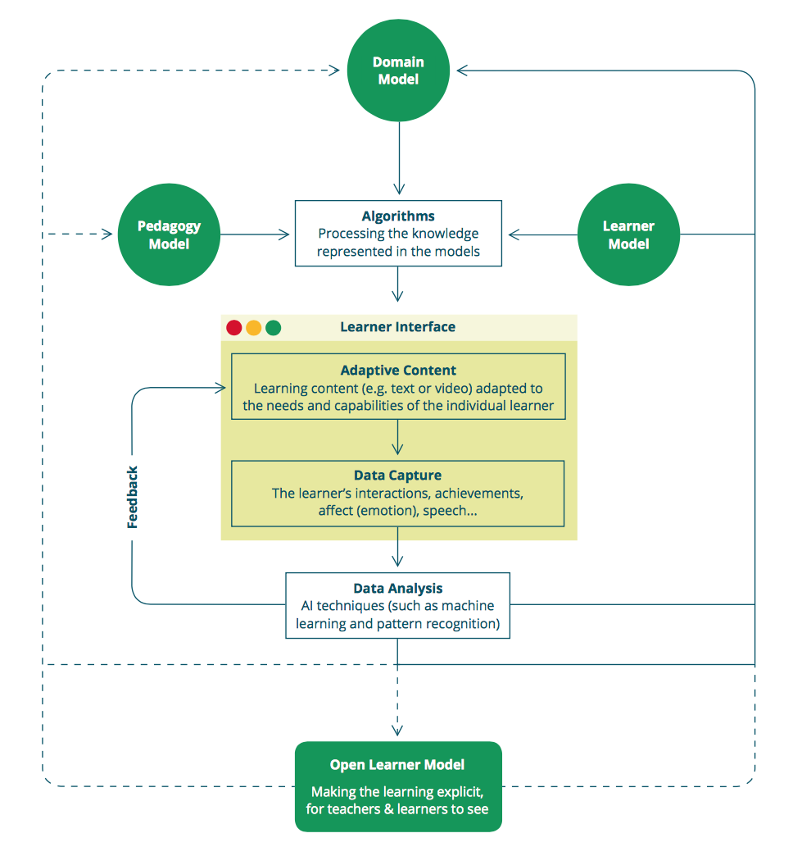

*Figure 1*. AIEd system showing a simplified picture of a typical model-based adaptive tutor.

Adapted from “Intelligence unleashed”, by Luckin,R., Holmes W. & Griffiths M., Forcier, B. 2016.

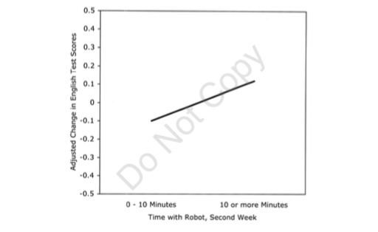

*Figure 2*. After 2 weeks, the change of English scores depending on the time spent with the robot.

Adapted from “Interactive robots as social partners”, by Kanda, T., Hirano, T., Eaton, D., and Ishiguro H. 2004. Copyright © 2004, Lawrence Erlbaum Associates, Inc.

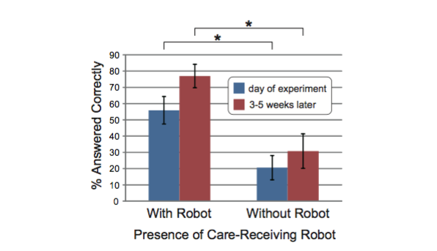

*Figure 3.* Post-test results. The figure shows the difference of correctly answered questions by children depending on the presence of a care-receiving robot.

Adapted from “Children teach a care-receiving robot to promote their learning”, Tanaka, F. and Matsuzoe, S. 2012.

Authors retain copyright and grant the Journal of Human-Robot Interaction right of first publication with the work simultaneously licensed under a Creative Commons Attribution License that allows others to share the work with an acknowledgement of the work’s authorship and initial publication in this journal.

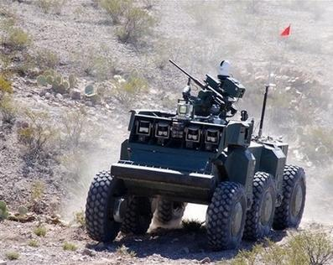

*Figure 4.* An example of autonomous weapon. Adapted from “Autonomous military robotics: Risk, ethics, and design”, by P. Lin, G. Bekey and K. Abney, 2008.

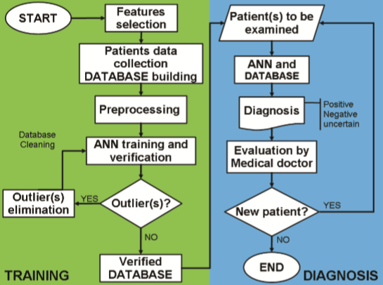

*Figure 5.* Diagram of the fundamental steps in Artificial neural networks based medical diagnosis. Adapted from “Artificial neural networks in medical diagnosis”, by Amato et al.,2013